# MongoDB Day 1 Task Answers :

Question 1 : Find all the information about each product.

db.products.find();

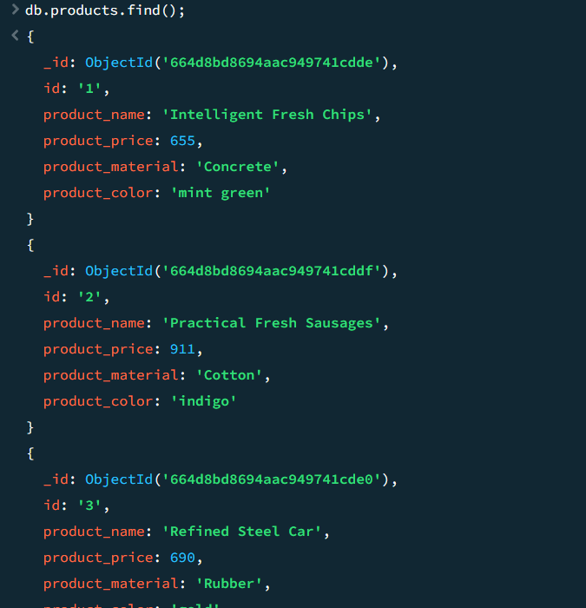

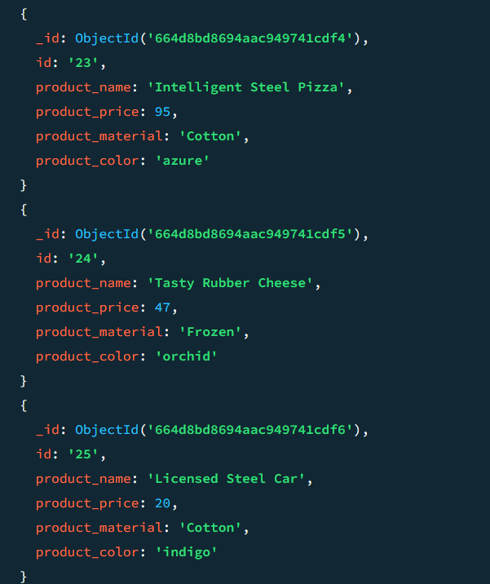

Question 2 : Find the product price which is between 400 to 800.

db.products.find({"product_price":{$gt:400,$lt:800}});

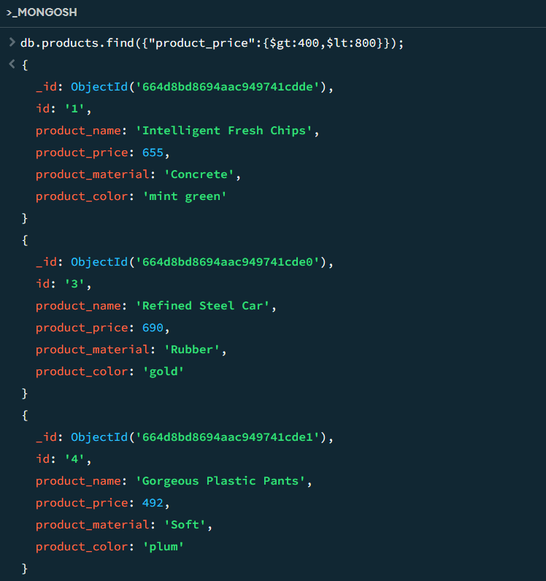

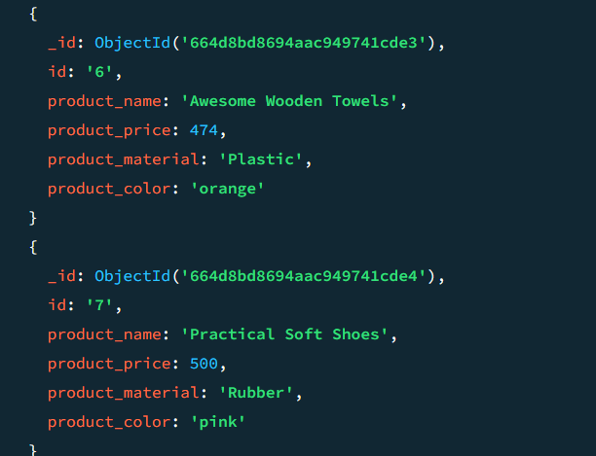

Question 3 : Find the product price which are not between 400 to 600 :

db.products.find({'product+price':{$ne:{$gt:400,$lt:600}}});

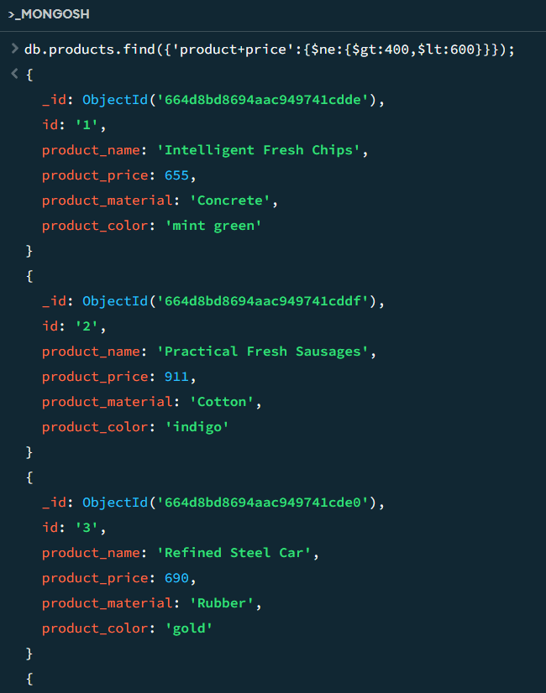

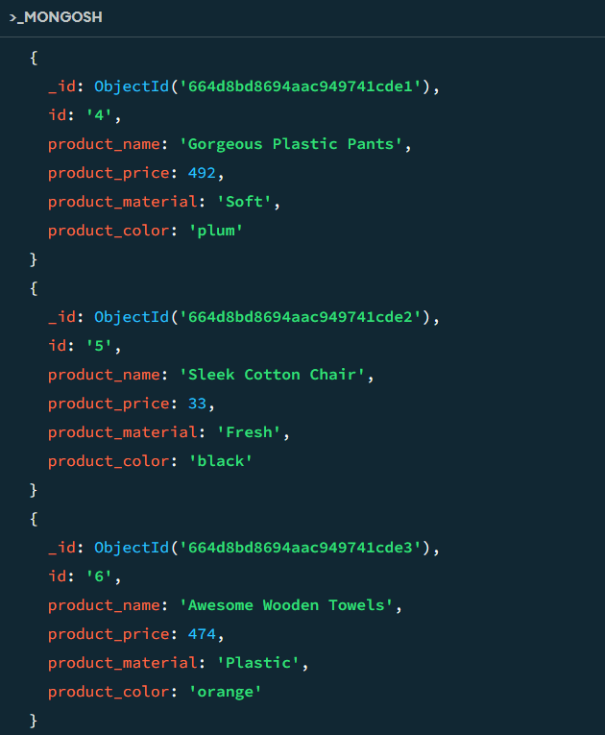

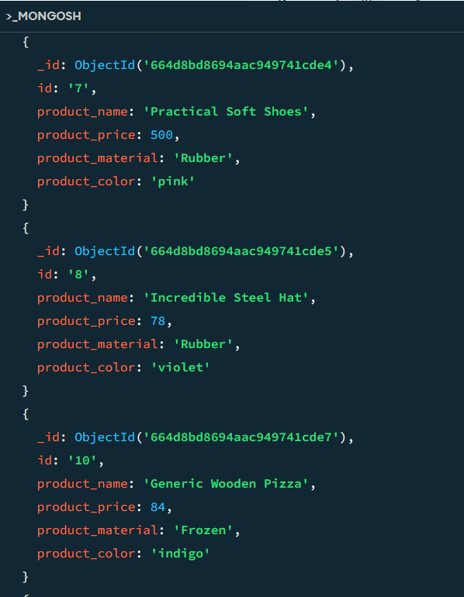

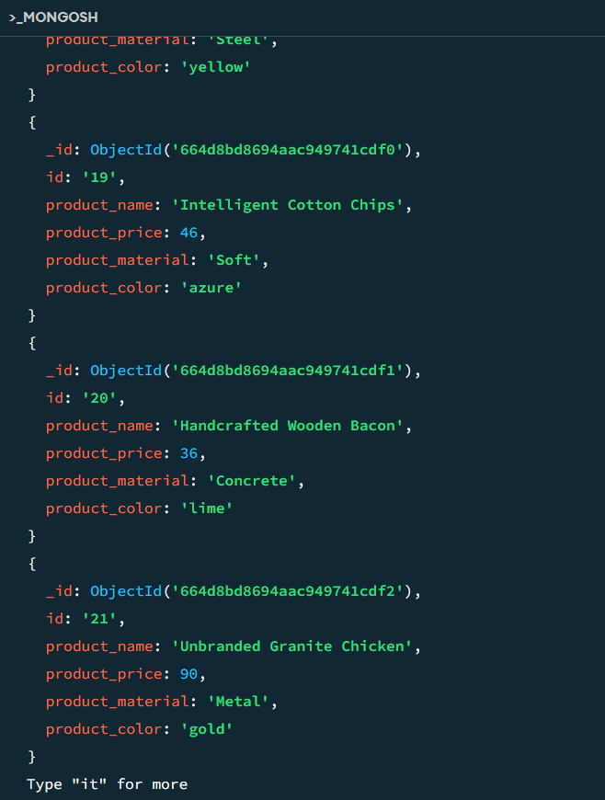

Question 4 : List the four product which are greater than 500 in price

db.products.find({'product_price':{$gt:500}}).limit(4);

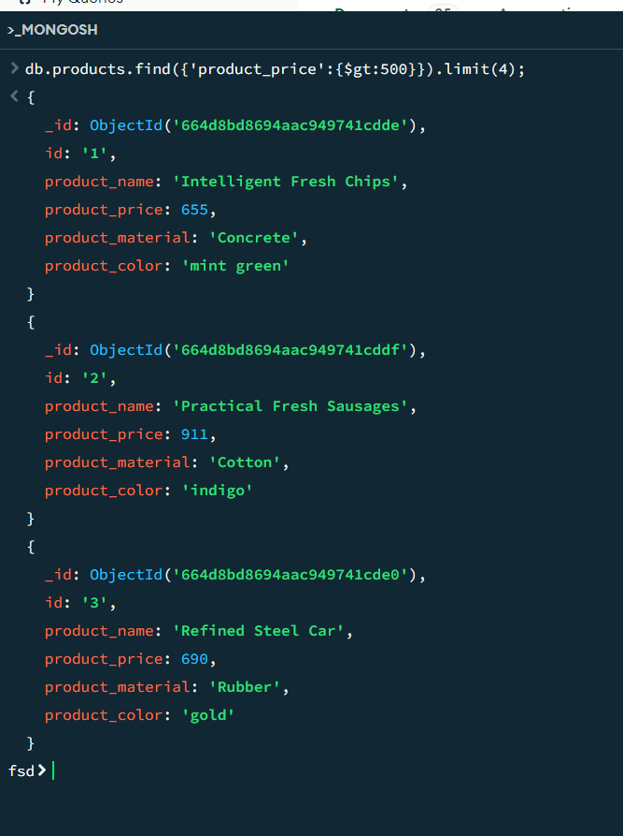

Question 5 : Find the product name and product material of each products.

db.products.find({},{'product_name':1,'product_material':1});

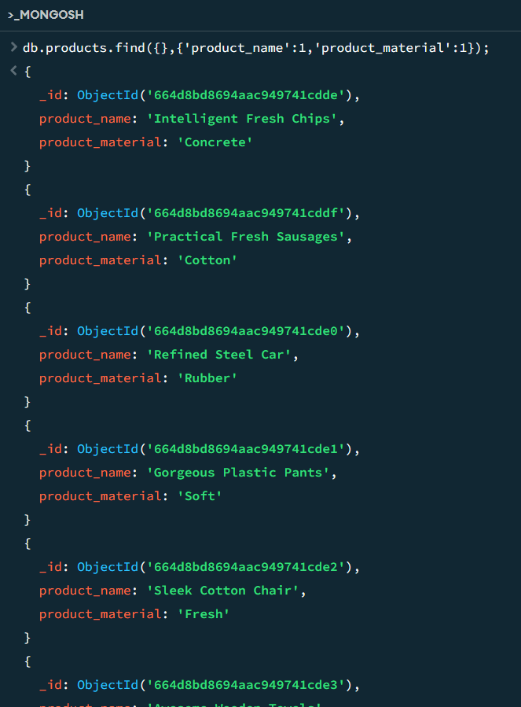

Question 6 : Find the product with a row id of 10.

db.products.find({'id':"10"});

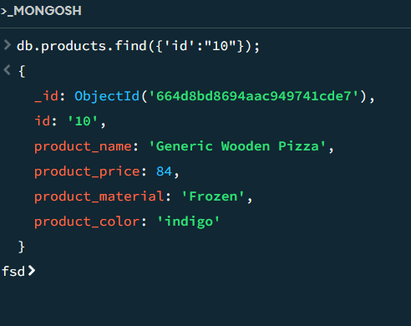

Question 7 : Find only the product name and product material

db.products.find({},{'product_name':1,'product_material':1,'_id':0});

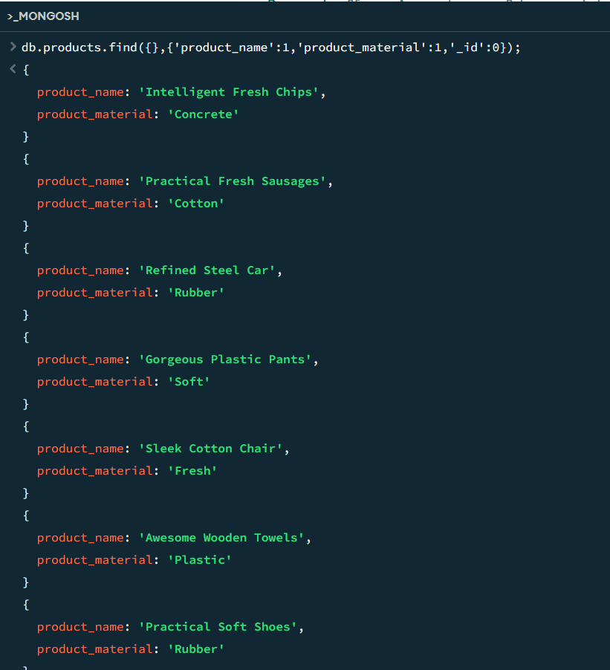

Question 8 : Find all products which contain the value of soft in product material.

db.products.find({'product_material':'Soft'});

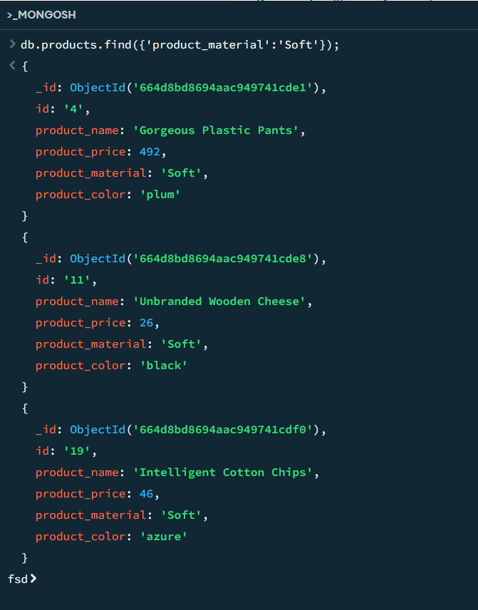

Question 9 : Find products which contain product color indigo and product price 492.00

db.products.find({$or:[{'product_color':'indigo'},{'product_price':492}]});

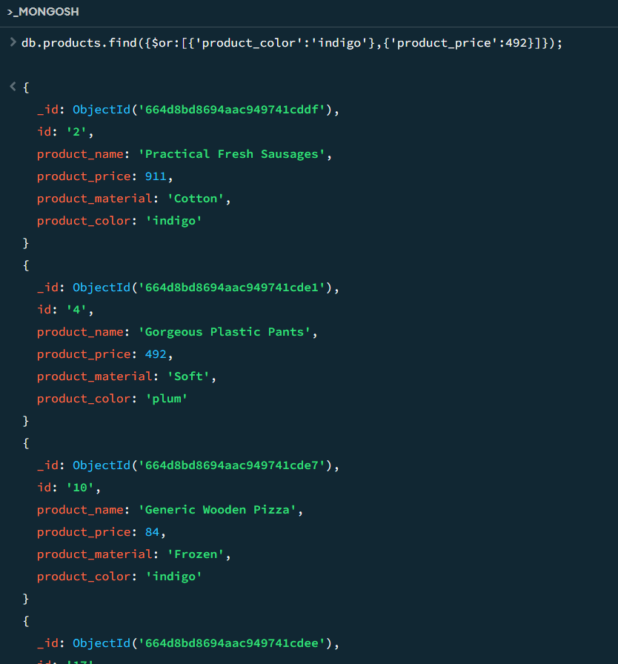

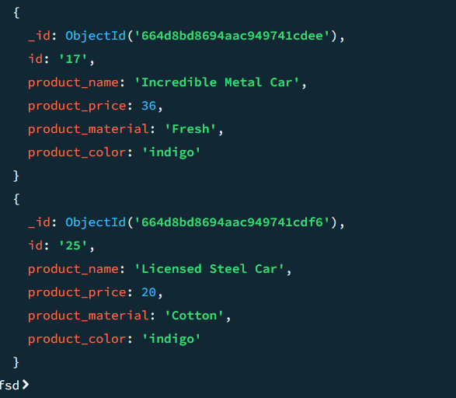

Question 10 : Delete the products which product price value are 28

db.products.deleteMany({'product_price':28});

